Week Ending: | DAY: |  |  |  | Subject: Mathematics
Duration: 60mins per lesson |  |  |  |  | Strand: Data
Class: B2 | Class Size: |  |  |  | Sub Strand: Data Collection And Organization
Content Standard:  B2.4.1.2 Construct and interpret concrete graphs and pictographs |  |  | Indicator:  B2.4.1.2.1 Draw and interpret concrete graphs and pictographs |  |  | Lesson:  1 OF 1
Performance Indicator:  Learners can draw and interpret concrete graphs and pictographs |  |  |  | Core Competencies:  Problem Solving skills; Critical Thinking; Justification of Ideas; Collaborative Learning; Personal
Teaching/ Learning Resources |  | Class registers, school based assessment
References: Mathematics Curriculum Pg. 40
DAYS | PHASE 1: STARTER | PHASE 2: MAIN | PHASE 3: REFLECTION
Monday | Ask learners questions to review their understanding in the previous lesson  Engage learners to play games and sing songs to begin the lesson. | Collecting data (objects)  Write the following subjects on the board and let learners show by hand which subject they like best, and state why.  A learner reads and writes the subject on the board  • Our World Our People (OWOP)  • Maths  • English  • French  Show learners a picture of different soft drinks and have them to count the different drinks and write the total number for each brand  Write these games on the board. Have learners determine the game they like best and make a stroke against it.  Football, Ampe, Netball, and Ludo | Homework  Count the number of the following items in your house. Write down the numbers for discussion the next day in class.  (spoons, bowls, cups, knifes)
Tuesday | Ask learners questions to review their understanding in the previous lesson  Engage learners to play games and sing songs to begin the lesson. | Collecting data (tally)  Write the following colors on the board. Have learners select the color they like best and tally it.  Color Tally Number  Red  Blue  Green  Yellow  Ask learner’s to indicate the drinks they like best. Guide them to put a tally in the columns as they answer the questions.  Learners in groups of five tell the fruit they like best and record it on the tally sheet. | Put a tally against the types of people in your house. Filling the total number.  Type of people Tally Number  Male  Female  Children
Wednesday | Ask learners questions to review their understanding in the previous lesson  Engage learners to play games and sing songs to begin the lesson. | Revise with learners on some of the key words used.  e.g. data, the number collected for the analysis, bar graph, etc.  Draw a bar graph on the board depicting the food learners like best  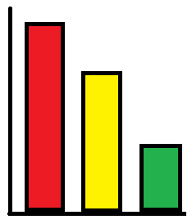  FUFU  BANKU  R  I  C  E  &  S  T  EW  Learners to use the graph to answer and/or pose questions, and justify the answers, based on the organized data  e.g. “What is the class favorite food? | Ask learners to tell you what they have learnt  Give learners individual or home task
Thursday | Ask learners questions to review their understanding in the previous lesson  Engage learners to play games and sing songs to begin the lesson. | Draw a bar graph on the board depicting learners favorite colors  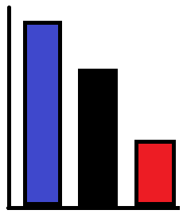  BLUE  BLACK  RED  Learners to use the graph to answer and/or pose questions, and justify the answers, based on the organized data  e.g. “What is the class favorite color?  Encourage learners to ask questions about the bar graph. | Ask learners to tell you what they have learnt  Give learners individual or home task
Friday | Ask learners questions to review their understanding in the previous lesson  Engage learners to play games and sing songs to begin the lesson. | Draw a bar graph on the board depicting learners favorite sports.  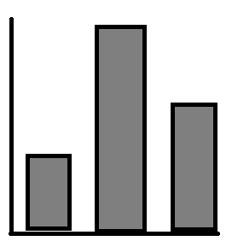  SOCCER  WRESTLING  AMPE  Learners to use the graph to answer and/or pose questions, and justify the answers, based on the organized data  e.g. “What is the class favorite sport?  Engage learners to collect data and represent it using bar graph.  Let learners answer questions based on the graph they have drawn. | Ask learners to tell you what they have learnt  Give learners individual or home task.

